|  |  |  |
| --- | --- | --- |
| Course: | **Artificial Intelligence** | Date: 28/06/2024 |
| Course Code: | CSC-325 | Session: I |
| Faculty’s Name: | Mr. Usama Imtiaz, Mr. Israr Akhter & Mr. Abdul Salam | Max Marks: 50 |
| Time Allowed: | 2.5 Hours | Total Pages: 13 |

* This is a closed-book exam. Communication devices and any written material is strictly prohibited.
* All questions are compulsory.
* Comprehension of questions is part of the exam. Use blue/black pen only.
* ***The answer sheet is not required****; solve your exam on the question paper.*
* Avoid attaching any extra sheets; use the last page for rough work.

|  |  |  |  |  |  |  |
| --- | --- | --- | --- | --- | --- | --- |
|  | **CLO 3** | **CLO 2** | **CLO 4** | **CLO 3** | **CLO 1** | **Total** |
| Question No # | **Q.1** | **Q.2** | **Q.3** | **Q.4** | **Q.5** |
| Total Marks | 12 Marks | 8 Marks | 15 Marks | 10 Marks | 5 Marks | **50 Marks** |
| Obtained Marks |  |  |  |  |  |  |

Student’s Name: _______________________ Enrollment No: _____________________

Invigilator's Name: _______________________ Signature: ________________________

**Question#1(2+2+2+2+2+2 Marks)….....………….....……….....………….....…..…..……(CLO-3)**

Suppose we have the following fitness function:

𝑓(𝑥) = 𝑥2 + 5

where (x) is a binary chromosome represented by a string of 6 bits (e.g., (x = 110100)). In order to calculate the fitness of a chromosome, you will need to convert the binary value into decimal first, and then apply the aforementioned fitness function. Please note that the fitness value is in decimal.

Assume 1-indexing, consider the following binary chromosomes:

|  |  |  |  |  |  |  |
| --- | --- | --- | --- | --- | --- | --- |
| Chromosome | Position  1 | Position  2 | Position  3 | Position  4 | Position  5 | Position  6 |
| A | 1 | 1 | 0 | 1 | 0 | 1 |
| B | 0 | 1 | 1 | 0 | 1 | 0 |
| C | 1 | 0 | 1 | 0 | 1 | 1 |
| D | 0 | 1 | 0 | 1 | 1 | 0 |

1. Calculate Fitness of all 4 chromosomes:

|  |
| --- |
|  |

1. Perform a single point crossover between chromosome B and D, **after position 3** and calculate the fitness values of the two offsprings (Chromosome E and F). Add these offsprings to the population.

|  |
| --- |
|  |

1. Perform a two-point crossover between chromosome A and C, **at positions 2 and 4 inclusive**, and calculate the fitness values of the two offsprings (Chromosome G and H). Add these offsprings to the population.

|  |
| --- |
|  |

1. Calculate the average fitness value of the population. Fill the following table on for your calculations.

|  |  |  |  |  |  |  |  |
| --- | --- | --- | --- | --- | --- | --- | --- |
| Chromosome | P1 | P2 | P3 | P4 | P5 | P6 | Fitness Value |
| A | 1 | 1 | 0 | 1 | 0 | 1 |  |
| B | 0 | 1 | 1 | 0 | 1 | 0 |  |
| C | 1 | 0 | 1 | 0 | 1 | 1 |  |
| D | 0 | 1 | 0 | 1 | 1 | 0 |  |
| E |  |  |  |  |  |  |  |
| F |  |  |  |  |  |  |  |
| G |  |  |  |  |  |  |  |
| H |  |  |  |  |  |  |  |

|  |
| --- |
|  |

1. Determine the optimal chromosome that would maximize the fitness function, and calculate its fitness value.

|  |
| --- |
|  |

1. Assume that you can generate new chromosomes by randomly choosing any position for both single-point and two-point crossovers, over a large number of iterations and substantial population size. Can you generate the optimal chromosome without mutation? if so, explain your answer briefly.

|  |
| --- |
|  |

**Question # 2 (8 Marks)………….....………..……….....………….....………….....…..…..……(CLO-2)**

Apply naïve bayes algorithm to predict the class of the given test data. Test data

**age<=30, Income=medium, Student=yes, Credit_rating=Fair (buys_computer = ?)**

Calculations are a must. Any solution without calculation will not be graded.

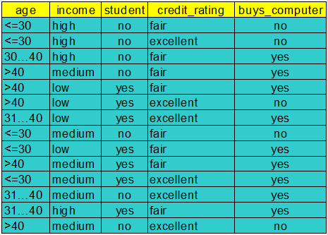

|  |
| --- |
|  |

**Question # 3 (15 Marks) .………….....…… .…… …… …….....…… .………….....…… (CLO-4)**

Consider the neural network below. Perform one forward pass and fix the error and update the weight for the given inputs and outputs. You need to be accurate in your calculations. Please perform calculations up to 4 decimal places. This shows the complete working of the algorithm; **fill in the table on the right**, no marks will be awarded without that. Direct answers will not get any marks.

**Inputs: i1 = 0.1, i2 = 0.5,**

**Output: o1 = 0.05, o2 = 0.95,**

**w1 = 0.1, w2 = 0.2, w3 = 0.3, w4 = 0.4, w5 = 0.5, w6 =0.6, w7 = 0.7 and**

**w8=0.8, n(learning rate) = 0.6**

Activation function in the neurons is sigmoid function.

|  |  |
| --- | --- |
| **H1** |  |
| **H1 out** |  |
| **H2** |  |
| **H2 out** |  |
| **E1** |  |
| **E2** |  |
| **Etotal** |  |
| **ΔW5** |  |
| **ΔW6** |  |
| **ΔW7** |  |
| **ΔW8** |  |

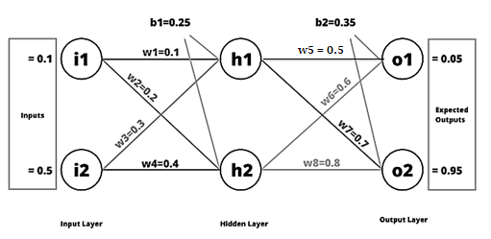



|  |
| --- |
|  |

**Question # 4 (10 Marks)** **……………………………………………………………………….(CLO-3)**

Consider the following clustering method called Leader Clustering. It receives two parameters: an integer *k* and a real number *t*. Similar to k-means, it starts by selecting k instances (which will be called leaders) and assigns each training instances to the cluster of the closest leader. During the assignment step, however, if the distance of a training instance to its closest leader is greater than the input threshold *t*, then this training instance becomes a new leader. During the same assignment step, remaining points can be assigned to these new leaders. After all the training instances have been assigned to a leader’s cluster, new leaders are calculated by averaging each cluster. The process is then repeated until the cluster assignments do not change.

1. Given a dataset and a value k, let t vary from 0 to a very large value. When does Leader Clustering produce more, the same number, or fewer clusters than k-means, assuming that the k initial centers are the same for both? When will the clusterings produced by Leader Clustering and k-means be identical?

|  |
| --- |
|  |

1. Which of the two methods, k-means or Leader Clustering, will be best at dealing with outliers (data instances that are ”far away” or very different to the other instances in the dataset)? Explain.

|  |
| --- |
|  |

**Question # 5 (2.5+2.5) Marks** **………………………………………….…….…….…….…(CLO-1)**

1. Explain the concept of backpropagation in a Multi-Layer Perceptron (MLP). How is the error propagated backward through the network, and how are the weights updated during training?

|  |
| --- |
|  |

1. Describe the training algorithm of a single-layer perceptron. How does the perceptron update its weights during training? Include the mathematical formula for the weight update rule.

|  |
| --- |
|  |